A book with more than100 Pages | A book more than 50 years old | 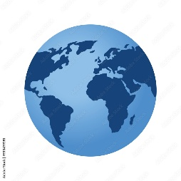  A book set  in a different  country | A book with a boy as the main character
A non-fiction book | 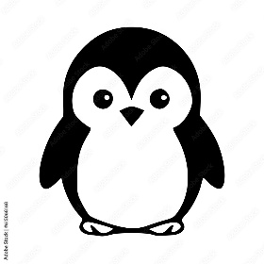  A book with  an animal  character | A book that is set in the past |   A book about someone famous
  A book that has been made  into a film | A funny book | A book with a green cover |   A book your friend loves
A book with a girl as the main character | A book with poems | A book with no words! | 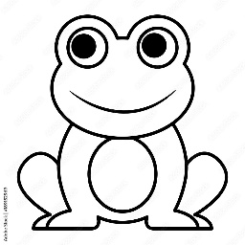  A book  with a frog
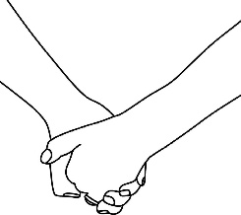  A book about friendship | A book written by your favourite author | A book with a colour in the title | 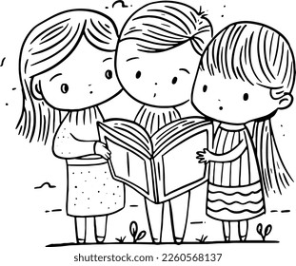
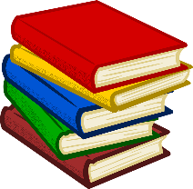
Book Bingo!

